**Лабораторна робота №4**

Савлук Максим ІПЗ-33

Варіант №18

Дано:

* Значення seedColor: Colors.green
* Крок лічильника: 4
* Іконка FloatingActionButton: Icons.camera_alt_outlined

Код:

import 'package:flutter/material.dart';  
  
void main() {  
 runApp(const MyApp());  
}  
  
class MyApp extends StatelessWidget {  
 const MyApp({super.key});  
  
 @override  
 Widget build(BuildContext context) {  
 return MaterialApp(  
 title: 'Flutter Demo',  
 theme: ThemeData(  
 colorScheme: ColorScheme.fromSeed(seedColor: Colors.*green*),  
 useMaterial3: true,  
 ),  
 home: const MyHomePage(title: 'Ipz-33: Maks First Flutter App'),  
 );  
 }  
}  
  
class MyHomePage extends StatefulWidget {  
 const MyHomePage({super.key, required this.title});  
  
 final String title;  
  
 @override  
 State<MyHomePage> createState() => _MyHomePageState();  
}  
  
class _MyHomePageState extends State<MyHomePage> {  
 int _counter = 0;  
  
 void _incrementCounter() {  
 setState(() {  
 _counter+=4;  
 });  
 }  
  
 @override  
 Widget build(BuildContext context) {  
 return Scaffold(  
 appBar: AppBar(  
 backgroundColor: Theme.*of*(context).colorScheme.inversePrimary,  
 title: Text(widget.title),  
 ),  
 body: Center(  
 child: Column(  
 mainAxisAlignment: MainAxisAlignment.center,  
 children: <Widget>[  
 const Text(  
 'You have pushed the button this many times:',  
 ),  
 Text(  
 '$_counter',  
 style: Theme.*of*(context).textTheme.headlineMedium,  
 ),  
 ],  
 ),  
 ),  
 floatingActionButton: FloatingActionButton(  
 onPressed: _incrementCounter,  
 tooltip: 'Increment',  
 child: const Icon(Icons.*camera_alt_outlined*),  
 ),  
 );  
 }

}

Web-версія застосунку:

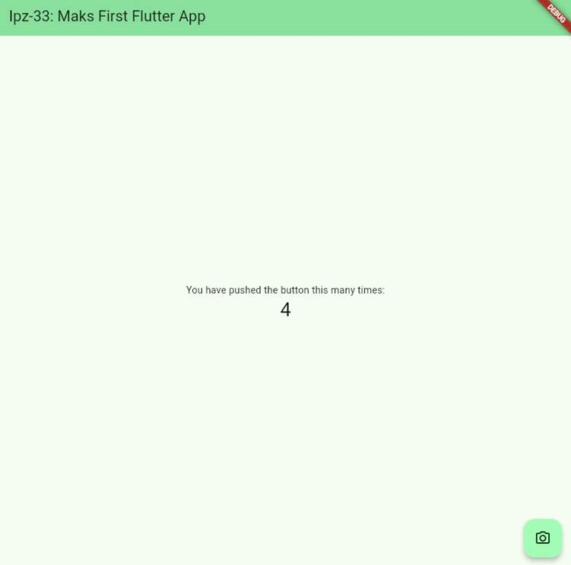

Мобільна версія застосунку:

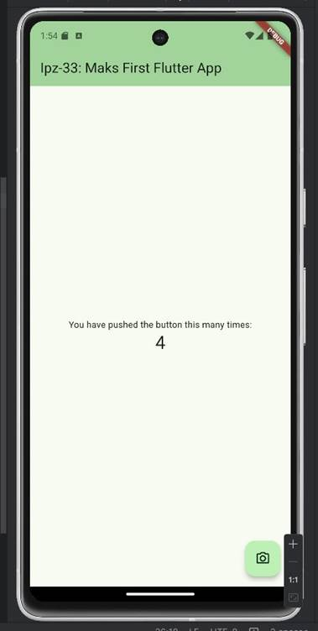

Посилання на додаток на <https://appetize.io>:

<https://appetize.io/app/b_hzgrf23qd552fbeoiqjmbuykia>

